# Being a designer

## Introduction

The material covered in the first part of this week’s lecture is drawn from a number of sources covering design and problem solving. The last part of the lecture covers chapter 3 of the team report.

## Is design important?

The question regarding the importance of design was raised at a national level in the UK in 2005 with the publication of the [Cox review](http://webarchive.nationalarchives.gov.uk/+/http:/www.hm-treasury.gov.uk/coxreview_index.htm). From that review we learn that design is the link between creativity and innovation.

‘Creativity’ is the generation of new ideas – either new ways of looking at existing problems, or of seeing new opportunities, perhaps by exploiting emerging technologies or changes in markets.

‘Innovation’ is the successful exploitation of new ideas. It is the process that carries them through to new products, new services, and new ways of running the business or even new ways of doing business.

‘Design’ is what links creativity and innovation. It shapes ideas to become practical and attractive propositions for users or customers. Design may be described as creativity deployed to a specific end.

The recommendation of the Cox review was the following: “Tackle the issue, in higher education, of broadening the understanding and skills of tomorrow’s business leaders, creative specialists, engineers and technologists. “

## What do we mean by design?

You will already have some ideas about what the word design means. You might think it is always about 'art' but in fact design can relate to many different topics. The Design Council include the following examples.

* Graphic design: using words and images to communicate and influence.
* Brand design: creating identity, 'personality', aspiration.
* Product design: forming the look ,feel, and functionality of 'things'
* Interaction design: the way people interact with technology.

## What are the characteristics of engineering design?

Engineering Design is a "purposeful activity directed toward the goal of fulfilling human needs, particularly those which can be met by technological factors, of our civilization." (M. Asimow, "Introduction to Design”, Prentice Hall). In his book "Introduction to Engineering Design", Svensson breaks this definition down into three components.

* A purposeful activity involving solving problems based on sound scientific principles within a defined time limit and taking into account factors such as economic, human, and legal.
  + Aimed at the satisfaction of human needs, indicating that designers must always know who they serve.
* Based on technological factors which separate engineering design from other areas that can fulfil human needs such as music, art, etc.

Engineering design can be characterised by a number of features. The following are not necessarily exhaustive. You might consider other characteristics to include.

* Goal orientated
  + - A problem needs to be solved. The problem may be well defined or ill defined.
* Variform (having various forms)
  + - There is no limit to the number of possible solutions.
* Constrained
  + - Natural laws, economics, human factors, legal factors, technology.
* Evolutive
  + - Changes may be required. These must be managed carefully especially if they come late in a ‘waterfall’ project lifecycle.
* Probabilistic
  + - There are always elements of uncertainty. A designer must take these into account in order to ensure the product meets the requirements.
* Value Comparative
  + - The final design is often ‘the best value’ choice from a number of solutions that have been compared for their ‘value’
* Compromising
  + - Compromise is often required in order to achieve the most effective solution.

## What are the characteristics of designers?

* An Ability to identify problems
  + Seeing a problem before anyone else can be a great advantage to a designer.
* Imaginative
  + Imagination is important for many aspects of design including future proofing, users, and the way in which the product is used, the environment in which the product is used. A designer should ‘imagine’ the product in use.
* Inventive
  + An inventive mind is essential to a designer.
* Sense of urgency
  + Quick thinking but maintaining effectiveness and avoiding panic.
* Ability to simplify problems
  + Simplifying problems can aid finding solutions but a designer must understand the consequences and limitations of the simplifications made.
* Numerate
  + Mathematical analysis is often required when seeking an engineering problem. In some the problem/solution may not require mathematical analysis but it is likely that logic will be required.
* Decisive
  + Decisions are required at all stages of product development. A good designer must be able to make decisions based on sound engineering principles.
* Open Minded
  + Change is always present and therefore a designer needs to be opening minded and to identify and adapt to change.

## Design processes

There are a number of ways of describing the process of design. Here I outline the 'double diamond' method and the 'SAFE' method.

‘Double diamond’ process model

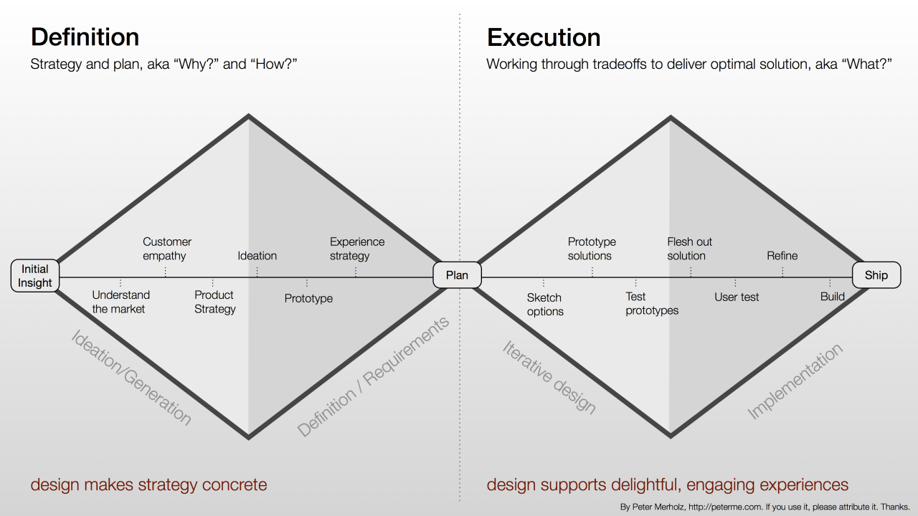

Figure 1 – Double diamond process model: Source: <http://rossbelmont.com/image/95916103788>

* Discover
  + Exploratory phase - very wide and open in thoughts and ideas
* Define
  + Focussing phase - bringing ideas together into a project
* Develop
  + Prototyping phase – building, assessing, revising...solutions
* Deliver
  + Launching phase - product support, conformance testing etc. - 'SAFE' process model
* Simple (i.e. paper clips)
* Appropriate (in context)
* Functional (serves the need)
* Economical (cost to make, buy, dispose...)

## System design

According to the Royal Academy of Engineering in their publication titled, "Creating Systems that Work", it is stated that, “A system is a set of parts which, when combined, have qualities that are not present in any of the parts themselves. Those qualities are the emergent properties of the system.” they note that emergent properties are often non-intuitive and that designs often have to iterate to converge on an acceptable solution.

### Levels of complexity in systems

Integrated system thinking is valuable when design spreads across disciplines where the scope and opportunity for misunderstanding varies with the complexity of the system. We can define levels of complexity.

* Level 1 -- A sub-system, substantially within one engineering discipline and one organisation E.g. PC motherboard, a car gearbox, and a secure encryption terminal
* Level 2 -- two or more engineering disciplines involved and/or require two or more organisations to design, build, operate or maintain it. E.g. electricity power station, railway signalling, a car.
* Level 3 -- A system of systems that impacts, or is impacted by, many disciplines and economic, social or environmental factors. E.g. national rail and roads network, the NHS, the telephone network and electricity supply.

### System design example

WWW is all pervasive, accessible to much of the world’s population. The US Defence Advanced Research Projects Agency (DARPA) mission was to create capability resilient to nuclear attack that could expand easily. The net expanded rapidly under formal system management and this led to the development of e-mail and file transfer, standardised communications protocols to improve resilience and ease of use. The breakthrough came in 1989 when Tim Berners-Lee, CERN, proposed a new protocol for embedding links in text, enabled the users to exchange information easily.

The key design message is get the architecture right in the first place and robustness, scalability and flexibility will follow

## The six principles of systems design

1. Debate, define, revise and pursue the purpose
2. Think holistic
3. Follow a disciplined procedure
4. Be creative
5. Take account of the people
6. Manage the project and the relationships

Read on these topics in the RAEng article on “Creating Systems that Work” in the [Chapter 3 initial reference material folder](https://moodle.essex.ac.uk/mod/folder/view.php?id=333420).

## Problem solving

You all have experience of problem solving and will recognise the following problems.

* How do I win at draughts (or, at least, not get beaten)?
* How do I program a computer to win at draughts?
* How do I draw four straight lines through a three by three grid of nine dots without taking pen from paper?
* Can we prove that our program is free of bugs?
* How should this circuit board be laid out?
* How will I pass this course / module?
* How do I get enough money to live while I am at University?
* How do I persuade the rest of the team that my point of view is valid?

The common features of the listed problems are that they all have a specific goal, the solver is not immediately able to achieve the goal because the goal is blocked either through a lack of resource or knowledge.

## Problem types

Problems can be categories into two type, well defined problems, and ill-defined problems.

### Well defined problems

These are problems in which the solver has all the information needed to solve the problem. The required information falls into four parts.

* The initial state of the problem
* The goal state
* The legal operators
* The operator restrictions

Example 1: I walk into a shop and purchase an item for 42p. I give the cashier a £20 note. What is the smallest number of a) notes and b) coins that they can give me as change?

Example 2: The towers of Hanoi. What is the smallest number of moves to move all the discs from the first to the last peg? How do I prove the answer is correct?

Well defined problems can be categorised as one of three types, Transformations (e.g. anagrams), Interpolations (e.g. Towers of Hanoi), and Synthesis (e.g. proving a theorem

<https://youtu.be/5QuiCcZKyYU>

### III defined problems

These types of problems are those for which there is little or no information provided regarding the initial state. The information about the legal operators or the operator restrictions may be incomplete, and even the outcome requested may be inadequately defined. In short with ill-defined problems, the solver has to help define the problem.

The following are all examples of ill-defined problems.

* How should this network be configured?
* How should this circuit board be laid out to optimise cost / performance?
* How can we implement this functionality within our software?
* Where should we site our new warehouse?
* What can we do to increase the gross profit margin without adversely affecting sales volumes?
* How do we stop war?

The characteristics of ill-defined problems are that there may be many formulations of the problem for example depending upon where you sit. There may be many solutions, varying for example in cost. There also may be no hard and fast right (or wrong) answer, with trade-off's apparent for different solutions.

In ill-defined problems the solver also plays a role as the knowledge of the solver can affect the degree to which the problem is considered ill-defined. A solver with prior experience of the problem or has been shown the solution to a similar problem, may have long term memory to augment the problem as stated.

### Complexity in problem solving

It is important not to confuse complexity and the difficulty in solving a problem with the degree to which it is well or ill-defined. Take for example the proving of Fermat's Last Theorem, which took 358 years to solve.

<https://youtu.be/pTqCawq1Zxw>

## Approaches to problem solving

### Approach 1 (‘How to Solve it’)

* Four main phases
  + Understand the problem
* The essential first step – may require research
* What is the goal state? What is the data? What conditions apply?
  + Plan an approach
* Look for the connections between the known and the unknown

### Approach 2 (Heuristics)

* *“a common-sense rule (or set of rules) intended to increase the probability of solving some problem”*
* “In engineering, heuristics are experience-based methods that are used to reduce the need for calculations”
* “Techniques that tend to work in some cases, but are not rigorously assured of success in general.”

### Approach 3 (State of the Art)

* [Koen (2003)](http://www.amazon.co.uk/Discussion-Method-Conducting-Engineering-Technology/dp/0195155998/ref=sr_1_2?s=books&ie=UTF8&qid=1417628866&sr=1-2&keywords=discussions+of+the+method) talks of SOTA the State of the Art
* The SOTA is a heuristic and a function of time
* Each of us has his or her own SOTA
  + As we learn and practice on problems the boundaries of our SOTA grow

### Approach 4 (Computational thinking)

* Analyse and logically organise data
* Describe the problem to enable computational solutions

### Approach 5 (Representing the problem)

* A monk climbs a hill starting at sunrise, varies his speed along the way and stops for rest at various points, reaching the top at sunset. The next day he descends the hill, again starting at sunrise….

### Approach 6 (Analogical problem solving)

* Solving problems through the use of analogies.
* Find a problem with a known solution where the problem is a structurally similar problem

### Approach 7 (Break it down)

* Read it through several times
  + Identify the principal parts
  + Restate/rephrase the problem, use a different representation (e.g. maths; a diagram; a model of some kind)
* What is known?
* What is the unknown?

### Approach 8 (Conjecture)

* A statement that appears OK but has not been proved.

### Approach 9 (Free thinking)

* Think first – judge later
  + (Suspend judgments – can be difficult to do!)
* Look for quantity, sift for quality

### Approach 10 (Select, test, socialise)

* Sift and select
* Test
* Model
* Socialise (seek opinions of others)